Session 3 -1

import java.util.*;

public class Solution {

static Iterator func(ArrayList mylist) {
Iterator it = mylist.iterator();
while (it.hasNext()) {
Object element = it.next();
if (element instanceof String) // Hint: This line possesses a string
break;
}
return it;
}

@SuppressWarnings({ "unchecked" })
public static void main(String[] args) {
ArrayList mylist = new ArrayList();
Scanner sc = new Scanner(System.in);
int n = sc.nextInt();
int m = sc.nextInt();
for (int i = 0; i < n; i++) {
mylist.add(sc.nextInt());
}

mylist.add("###");
for (int i = 0; i < m; i++) {
mylist.add(sc.next());
}

Iterator it = func(mylist);
while (it.hasNext()) {
Object element = it.next();
System.out.println((String) element);
}
sc.close();
}
}

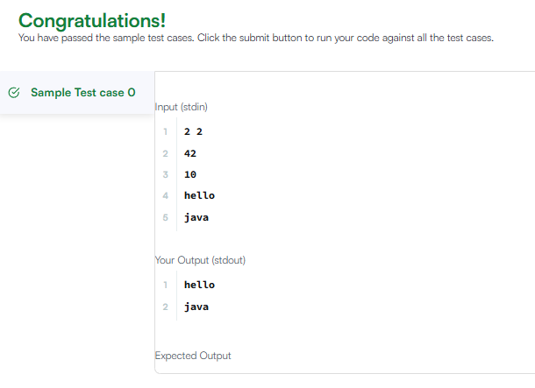

Session 3 - 2

import java.util.*;

interface AdvancedArithmetic {
int divisor_sum(int n);
}

class MyCalculator implements AdvancedArithmetic {
public int divisor_sum(int n) {
int sum = 0;
for (int i = 1; i <= n; i++) {
if (n % i == 0) {
sum += i;
}
}
return sum;
}
}

public class Solution {
public static void main(String[] args) {
MyCalculator my_calculator = new MyCalculator();
System.out.print("I implemented: ");
ImplementedInterfaceNames(my_calculator);
Scanner sc = new Scanner(System.in);
int n = sc.nextInt();
System.out.print(my_calculator.divisor_sum(n) + "\n");
sc.close();
}

static void ImplementedInterfaceNames(Object o) {
Class[] theInterfaces = o.getClass().getInterfaces();
for (int i = 0; i < theInterfaces.length; i++) {
String interfaceName = theInterfaces[i].getName();
System.out.println(interfaceName);
}
}
}

